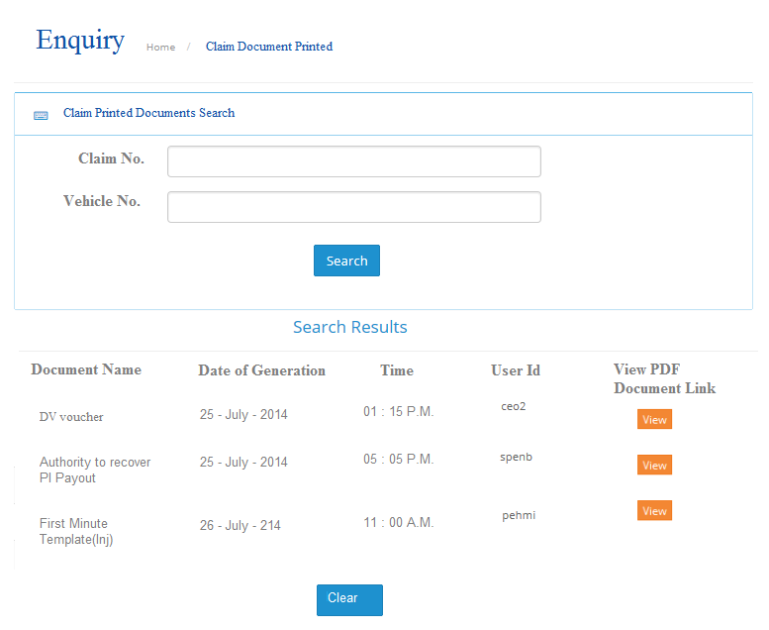

Drop down list but Must have smart search filtering otherwise the listing will be too long. Smartsearch is where as user key in a few chars, the system is able to filter out claims or vehicle no. meeting the few data and display for selection